**Key Performance Indicators (KPIs)**

**Total Loan Applications:**

SELECT count(id) AS Total_applications FROM bank_loan;

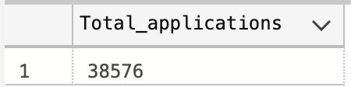

**MTD Loan Application:**

SELECT count(id) AS MTD_Total_applications FROM bank_loan

WHERE MONTH(issue_date) = 12 AND YEAR(issue_date) = 2021;

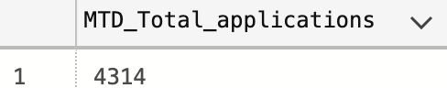

**Total Funded Amount:**

SELECT SUM(loan_amount) AS Total_Funded_Amount FROM bank_loan;

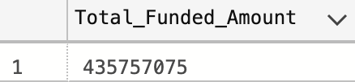

**PMTD Loan Application:**

SELECT count(id) AS PMTD_Total_applications FROM bank_loan

WHERE MONTH(issue_date) = 11 AND YEAR(issue_date) = 2021;



**Total Amount Recieved:**

SELECT SUM(total_payment) AS Total_Amount_Recieved FROM bank_loan;



**MTD total amount Received:**

SELECT SUM(total_payment) AS Total_Amount_Recieved FROM bank_loan

WHERE YEAR(issue_date) = 2021 AND MONTH(issue_date) = 12;

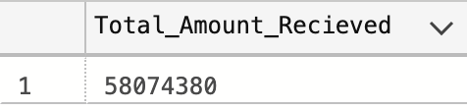

________________________________________________________________________

**Average Interest Rate:**

SELECT ROUND(AVG(int_rate) * 100, 2) AS Avg_Interest_Rate FROM bank_loan;

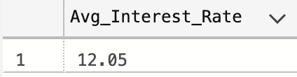

**MTD Average Interest**

SELECT ROUND(AVG(int_rate) * 100, 2) AS Avg_Interest_Rate FROM bank_loan

WHERE MONTH(issue_date) = 12 AND YEAR(issue_date) = 2021;

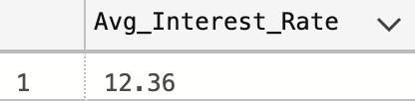

**PMTD Average Interest**

SELECT ROUND(AVG(int_rate) * 100, 2) AS Avg_Interest_Rate FROM bank_loan

WHERE MONTH(issue_date) = 11 AND YEAR(issue_date) = 2021;

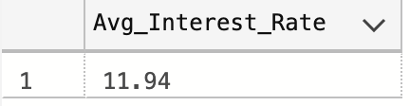

**Avg Debt-to-income- ratio, DTI:**

SELECT ROUND(Avg(dti) * 100, 4) AS Avg_DTI FROM bank_loan;

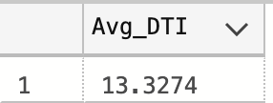

**MTD Avg DTI**

SELECT ROUND(Avg(dti) * 100, 4) AS Avg_DTI FROM bank_loan

WHERE MONTH(issue_date) = 12 AND YEAR(issue_date) = 2021;

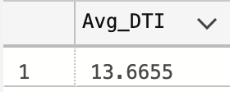

**Good Loans Issued**

**Types of Loan:**

SELECT loan_status FROM bank_loan GROUP BY loan_status;

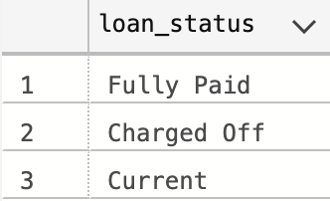

**Good Loan Percentage:**

SELECT

(COUNT(CASE WHEN loan_status = 'Fully Paid' OR loan_status = 'Current' THEN id END)) * 100

/

COUNT(id) AS Good_loan_percentage

FROM bank_loan;

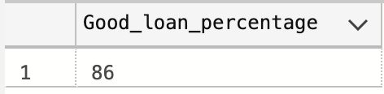

**Good Loans Applications**

SELECT COUNT(loan_status) AS Total_Good_Loan FROM bank_loan

WHERE loan_status = 'Fully Paid' OR loan_status = 'Current';

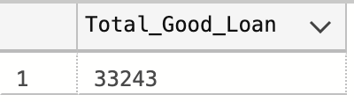

**Good Loan Funded Amount**

SELECT SUM(loan_amount) AS Good_Loan_Funded_Amount FROM bank_loan

WHERE loan_status = 'Fully Paid' OR loan_status = 'Current';

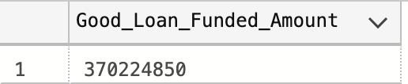

**Good Loan Recieved Amount**

SELECT SUM(total_payment) AS Good_Loan_Recieved FROM bank_loan

WHERE loan_status = 'Fully Paid' OR loan_status = 'Current';



Note: This means the bank is making a profit since the received amount for good loans is much bigger than the funded amount! These clients can be trusted with more loans.

**Bad Loans Issued**

**Bad Loan Percentage:**

SELECT

(COUNT(CASE WHEN loan_status = 'Charged Off' THEN id END)) * 100

/

COUNT(id) AS Bad_loan_percentage

FROM bank_loan;

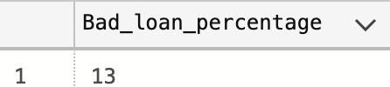

**Bad Loan Applications**

SELECT COUNT(id) AS Bad_loan_applications FROM bank_loan

WHERE loan_status = 'Charged Off';

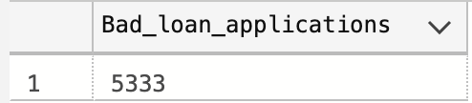

**Bad Loan Funded Amount**

SELECT SUM(loan_amount) AS Bad_loan_funded_amount FROM bank_loan

WHERE loan_status = 'Charged Off';

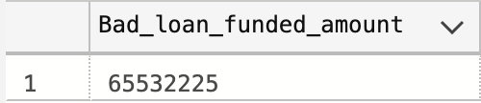

**Bad Loan Recieved Amount**   
SELECT SUM(total_payment) AS Bad_loan_recieved_amount FROM bank_loan

WHERE loan_status = 'Charged Off';

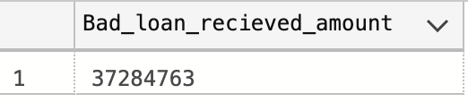

Note: Funded Amount much lower than received amount, meaning bank lost money. These customers must be investigated.

**Loan Status**

SELECT

loan_status,

COUNT(id) AS LoanCount,

SUM(total_payment) AS Total_Amount_Received,

SUM(loan_amount) AS Total_Funded_Amount,

AVG(int_rate * 100) AS Interest_Rate,

AVG(dti * 100) AS DTI

FROM bank_loan

GROUP BY loan_status;

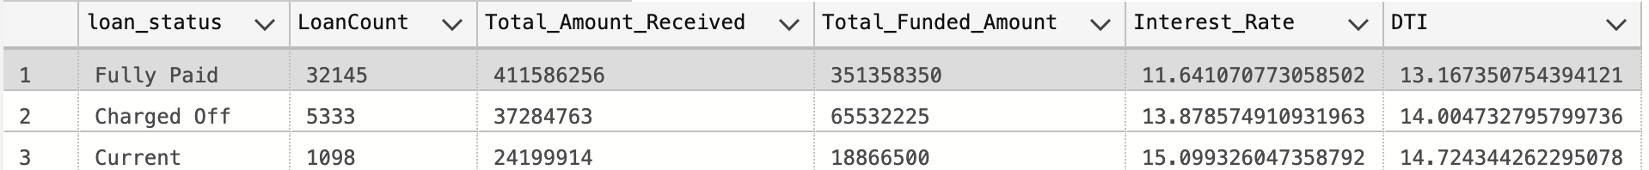

**MTD Loan Status**

SELECT

loan_status,

SUM(total_payment) AS Total_Amount_Received,

SUM(loan_amount) AS Total_Funded_Amount

FROM bank_loan

WHERE MONTH(issue_date) = 12 AND YEAR(issue_date) = 2021

GROUP BY loan_status;

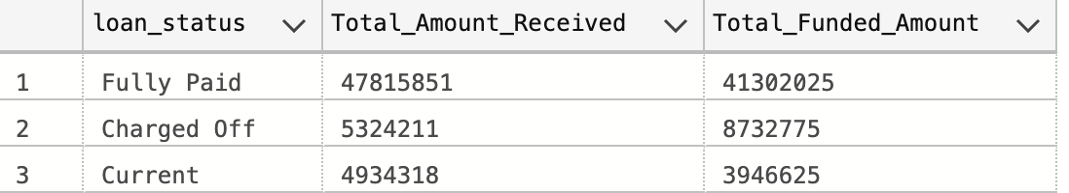

_____________________________________________________________________________

**Bank Loan Report Overview**

**Month:**

SELECT

MONTH(issue_date) AS Month_Munber,

DATENAME(MONTH, issue_date) AS Month_name,

COUNT(id) AS Total_Loan_Applications,

SUM(loan_amount) AS Total_Funded_Amount,

SUM(total_payment) AS Total_Amount_Received

FROM bank_loan

GROUP BY MONTH(issue_date), DATENAME(MONTH, issue_date)

ORDER BY MONTH(issue_date);

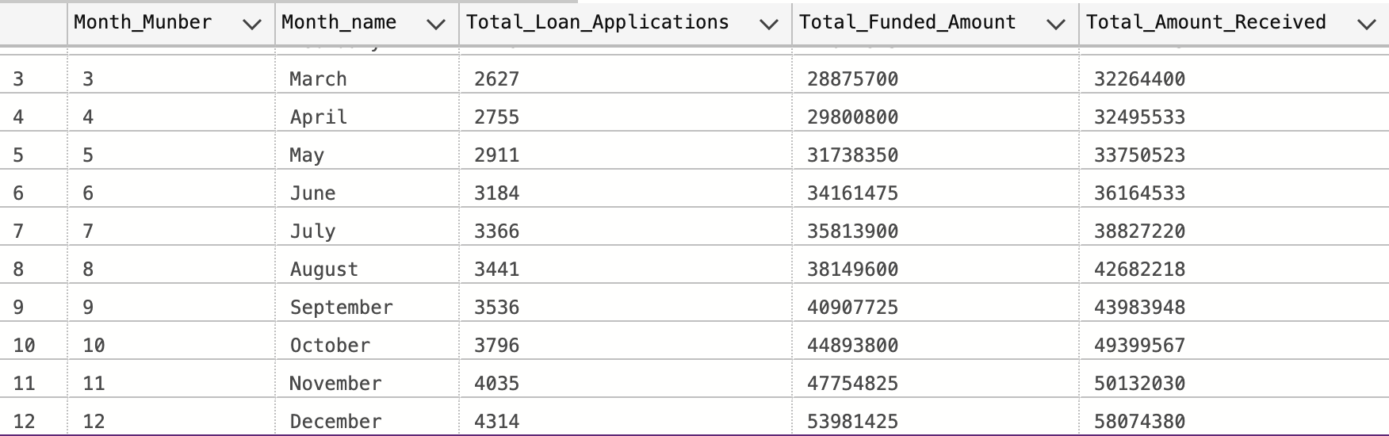

**Address/State**

SELECT

address_state AS State,

COUNT(id) AS Total_Loan_Applications,

SUM(loan_amount) AS Total_Funded_Amount,

SUM(total_payment) AS Total_Amount_Received

FROM bank_loan

GROUP BY address_state

ORDER BY address_state;

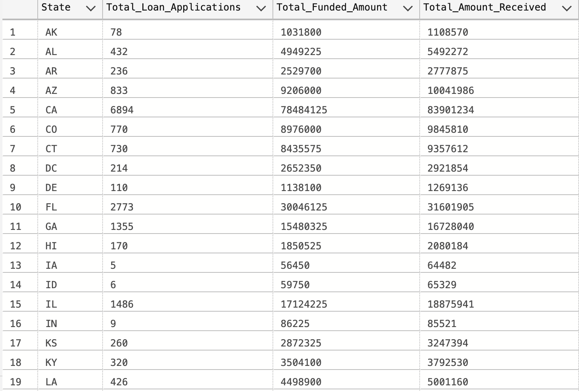

**Employee Length**

SELECT

address_state AS State,

COUNT(id) AS Total_Loan_Applications,

SUM(loan_amount) AS Total_Funded_Amount,

SUM(total_payment) AS Total_Amount_Received

FROM bank_loan

GROUP BY address_state

ORDER BY address_state;

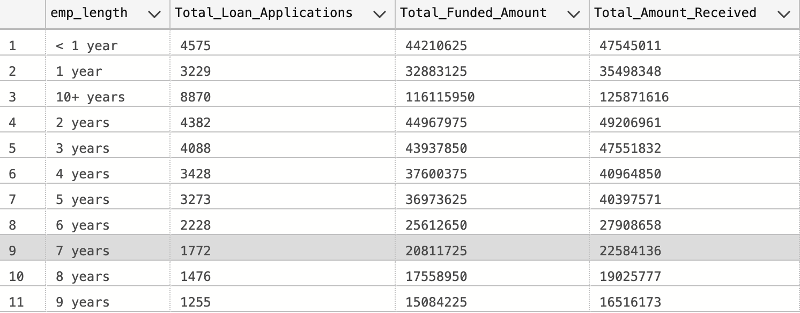

**Purpose**

SELECT

purpose AS purpose,

COUNT(id) AS Total_Loan_Applications,

SUM(loan_amount) AS Total_Funded_Amount,

SUM(total_payment) AS Total_Amount_Received

FROM bank_loan

GROUP BY purpose

ORDER BY purpose;

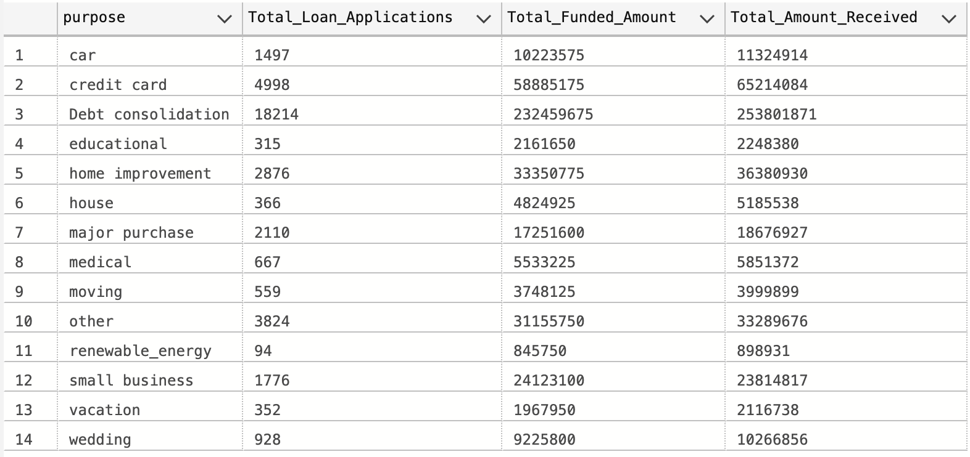

**Home Ownership**

SELECT

home_ownership AS home_ownership,

COUNT(id) AS Total_Loan_Applications,

SUM(loan_amount) AS Total_Funded_Amount,

SUM(total_payment) AS Total_Amount_Received

FROM bank_loan

GROUP BY home_ownership

ORDER BY COUNT(id) DESC;

